tPad: A Contact Augmented Reality Implementation  
to Support Active Reading

|  |  |  |
| --- | --- | --- |
| 1st Author Name  Affiliation  Address  e-mail address  Optional phone number | 2nd Author Name  Affiliation  Address  e-mail address  Optional phone number | 3rd Author Name  Affiliation  Address  e-mail address  Optional phone number |

# ABSTRACT

Permission to make digital or hard copies of all or part of this work for personal or classroom use is granted without fee provided that copies are not made or distributed for profit or commercial advantage and that copies

bear this notice and the full citation on the first page. To copy otherwise, or republish, to post on servers or to redistribute to lists, requires prior specific permission and/or a fee.

## Author Keywords

## ACM Classification Keywords

## General Terms

# INTRODUCTION

Transparent displays allow showing digital information while maintaining visible the physical objects in the background; making them ideal for applications like car wind-shields [1], vending machines [2] and shop-windows [3]. Such displays are also used for augmented reality purposes, that is, linking the digital information to the real world objects behind the display [4]. Upcoming portable transparent displays enable a new kind of augmented reality where the display rests directly on top of the physical object it augments; we call it *Contact Augmented Reality* (cAR).

In this paper we explore the notion of cAR by identifying *device* *registration* as the main challenge and exploring novel opportunities for interaction. For CAR, device registration deals with determining the 2D location and orientation of the device in relation to the surface of object over which it rests. Handling device registration clears the way for novel opportunities for interaction including dual side output and device composition by stacking.

We built two prototype cAR devices: a low-fidelity tabletop emulation and a 7” portable device called the tPad. The tabletop prototype relays the registration problems to an external 3D tracking system, and allowed us to explore the different interaction techniques with minimal implementation demands. The tPad prototype addresses the registration problem by using a camera-based feature tracking approach. The tPad uses a capacity-overlay for touch input. Finally, a controller board detects the tPad's flipping or whether it's stacked with another one.

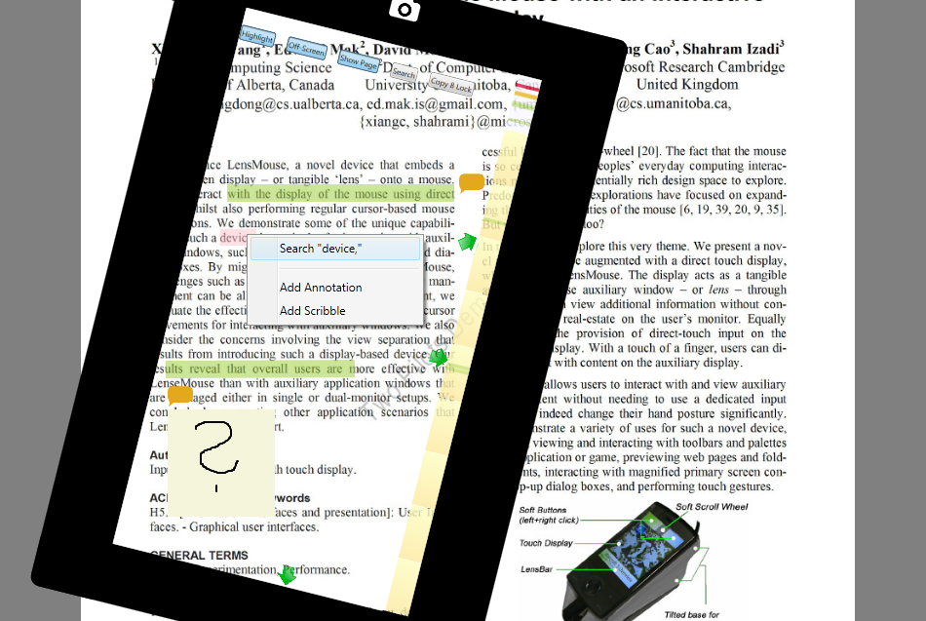

Figure 1: tPad screen capture showing highlights (green) , text and free-hand annotations, and off-screen pointers (arrow).

We explore cAR and the tPad in an Active Reading scenario [5]. Active Reading describes a combination of reading with critical thinking and learning. Through a user-centered design process we built the ActiveReader, an application for the tPad that allows users to underline, highlight, scribble comments, search content, and look-up references (see Figure 1). Users access special information by flipping the tPad, and two tPads can share content when staked-up. Users can later retrieve their annotations from their personal computer.

We studied the ActiveReader tPad application with users in active reading tasks. The task required using all the tPad features like touch, flipping and staking. Initial feedback shows that using the tPad is highly intuitive and learn-able. Moreover, users highlighted the value of reading on paper, having the digital features when needed, and being able to access their annotations digitally.

Our contributions are at the conceptual, interaction design, and technical levels. First, we introduce the notion of Contact Augmented Reality and propose a series of interaction techniques. Second, we present a prototype implementation called the tPad. Third, we show how the tPad and the CAR notion can be applied to the active reading scenario. Fourth, we collect initial user feedback that shows how active reading benefits from the tPad and its ActiveReader application.

# RELATED WORK

### Augmented Reality

HMDs and Handheld

### Spatial Augmented Reality

Fixed in relation to the object

Projectors, transparent displays

### Virtual Lenses

Mackays ABook – say that we were inspired by this work and we generalize this initial exploration into the concept of cAR. However, we depart in several ways: first we use a camera based registration, second we explore off-contact and transparent interactions, third we rely on transparent display technology.

# Contact Augmented Reality - cAR

Definition: mobile device which augments when coming in close contact (overlay) with the augmented surface.

How is it different than normal or spatial: 1) Activated upon contact, else the device works as a normal mobile device 🡪 it is not handheld as it needs the surface.

2) Spatially aligned -> registration problem is reduced to finding the location of the device in relation to the surface, no need to track the user.

3) Interaction techniques that are contact-based, content-aware, and off-contact (like a normal mobile device).

# Approach

We used Active Reading as an application scenario and an inspiration tool to brainstorm and elicit features and interaction techniques.

Design sessions

Prototype 1 - Tabletop

Prototype 2 - tPad

# cAR Interaction Techniques

Contact-based

Content-aware

Off-Contact

# Tabletop Prototype

Implementation Details: registration, display and render details.

Features

Feedback

# tPad Prototype

Implementation Details: registration, display and render details.

Features – features that are not contact, reinforce the need of paper, talk about on-the-fly model generation

Feedback

# Discussion

# Conclusions

Actual conclusions

Future work

# REFERENCES

1. OR A. Doshi, S. Y. Cheng, and M. M. Trivedi, “A novel active heads-up display for driver assistance,” IEEE Trans. Syst., Man, Cybern. B, Cybern., vol. 39, no. 1, pp. 85–93, Feb. 2009.
2. Japan’s transparent display vending machine. <http://techcrunch.com/2011/12/20/video-japan-vending-machine-2-0/>
3. Abhijit Karnik, Walterio Mayol-Cuevas, and Sriram Subramanian. 2011. MUST-D: multi-user see through display. In Proceedings of the 24th annual ACM symposium adjunct on User interface software and technology (UIST '11 Adjunct). ACM, New York, NY, USA, 77-78.
4. M. J. Adler and C. Van Doren. How to Read a Book. Revised edition, Simon and Schuster, New York, 1972.

**The columns on the last page should be of approximately equal length.   
Remove these two lines from your final version.**